Tyrone Russ

Russ consulting services, inc

Software Requirement Specification

**People’s Bankruptcy Software**

**Table of Contents**

**1.** **Introduction** 2

**1.1**  **Purpose** 2

**1.2** **Scope** 2

**1.3** **Definitions, Acronyms, and Abbreviations – See Appendix A: Glossary** 2

**1.4** **References** 2

**1.5** **Overview** 3

**2.** **Overview Description** 4

**2.1** **Product Perspective** 4

**2.2** **Product Functions** 6

**2.3** **User Characteristics** 7

**2.4** **Constraints** 7

**2.5** **Assumptions and Dependencies** 7

**3.** **Systems Requirements** 8

**3.1**  **Interface Requirements** 8

**3.1.1** **User Interfaces** 8

**3.1.2** **Hardware Interfaces** 8

**3.1.3** **Software Interfaces** 8

**3.1.5** **Communication Interfaces** 8

**3.2**  **Functional Requirements** 9

**3.2.1** **Manage Users** 9

**3.2.2** **Case Management** 9

**3.2.3** **Document Management (view and print)** 9

**3.2.4** **State / Federal Rules** 9

**3.2.5** **Electronic filing (Pacer)** 9

**3.2.6** **Help system** 9

**3.2.7** **Security system** 9

**3.3**  **Performance requirements** 10

**3.4**  **Design constraints** 10

**3.5**  **Software system attributes** 10

**4.** **Prioritization of Release Plans** 10

**4.1.** **Choice of prioritization Method** 10

**4.2.** **Release Plan** 10

**pixel.gif (42 bytes)Appendix A:** 11

**Bankruptcy Glossary** 11

**Terms and descriptions** 11

# **Introduction**

This section gives a scope description and overview of everything included in this SRS document. Also, the purpose for this document is to described the system and create a list of abbreviations and definitions.

## **1.1 Purpose**

The purpose of this document is to give a detailed description of the requirements for the “Bankruptcy Application”. It will illustrate the purpose and complete declaration for the development of the system. It will also explain system constraints, interface and interactions with other external applications. This document is primarily intended for developing the first version of the system for the newly formed development team.

## **1.2 Scope**

The “People’s Bankruptcy Software” is an Online and/or PC based application which helps people to a file Chapter 7, 11, 12, or 13 Bankruptcy. An administrator also uses the web-portal in order to administer the system and keep the information accurate. The administrator can, for instance, maintain system reliability, updates, and manage user information.

Furthermore, the software will need Internet and connection to fetch data for required updates from Government sites. All system information is maintained in a database, which is hosted on a remote web-server if the online version. The application also has the capability of representing both summary and detailed information about the bankruptcy laws and filing requirements.

## **1.3 Definitions, Acronyms, and Abbreviations – See Appendix A: Glossary**

|  |  |
| --- | --- |
| **Terms (Technical)** | **Definition** |
| User | Someone who interacts with the People’s Bankruptcy Software |
| Admin/Administrator | System administrator who is given specific permission for managing and controlling the information on the system |
| Web-Portal | A web application which present special features and functionality via Web |
|  |  |
|  |  |
|  |  |

## **1.4 References**

[1] IEEE Software Engineering Standards Committee, “IEEE Std 830-1998, IEEE Recommended Practice for Software Requirements Specifications”, <https://www.computer.org/web/standards/s2esc>

[2] Davis M A, “Just Enough Requirements Management: Where Software Development Meets Marketing”, New York, Dorset House Publishing, 2005.

## **1.5 Overview**

The remainder of this document includes three chapters and appendixes. The second one provides an overview of the system functionality and system interaction with other systems. This chapter also introduces different types of stakeholders and their interaction with the system. Further, the chapter also mentions the system constraints and assumptions about the product.

The third chapter provides the requirements specification in detailed terms and a description of the different system interfaces. Different specification techniques are used in order to specify the requirements more precisely for different audiences.

The fourth chapter deals with the prioritization of the requirements. It includes a motivation for the chosen prioritization methods and discusses why other alternatives were not chosen.

The Appendixes in the end of the document include the all results of the requirement prioritization and a release plan based on them.

# **Overview Description**

This section will give an overview of the whole system. The system will be explained in its context to show how the system interacts with other systems and introduce the basic functionality of it. It will also describe what type of stakeholders that will use the system and what functionality is available for each type. At last, the constraints and assumptions for the system will be presented.

## **2.1 Product Perspective**

This system will consist of two parts: PC/Desktop application and a Web Portal. The PC/Desktop application will be used as a standalone sold to individual users. While the web portal will be used for managing the information for multiple clients via subscriptions (primarily for Attorneys or Law firms).

The People’s Bankruptcy application will be run on the Linux operating system as seen in diagram 1.0 below. The People’s Bankruptcy Software will provide the interface and outputted PDF forms required for the filings, along with the necessary legal guidance to lead to a successful Chapter 7 discharge. The functionality provided to the user will be embedded into the application in order for the user to be able to use the functions in the application in a seamlessly manner.

The following diagram illustrates the process flow of the communication that takes place between the client and server.

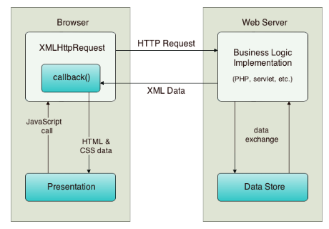

Process Flow Diagram 1.0

The process flow of the diagram can be described by the following steps:

1. The user triggers an event, for example by releasing a key when typing in a name. This results in a JavaScript call to a function that initializes an XMLHttpRequest object.
2. The XMLHttpRequest object is configured with a request parameter that includes the ID of the component that triggered the event, and any value that the user entered. The XMLHttpRequest object then makes an asynchronous request to the web server.
3. On the web server, an object such as a servlet or listener handles the request. Data is retrieved from the data store, and a response is prepared containing the data in the form of an XML document.

Finally, the XMLHttpRequest object receives the XML data using a callback function, processes it, and updates the HTML DOM (Document Object Model) to display the page containing the new data. Since this is a data-centric product it will need somewhere to store the data. For that, a database will be used for both the PC/Desktop application and the web portal, however in slightly different ways. The application will use XML data files as seen in middleware system to get and post data while the Business Logic implementation minimize the database communicate required over the Internet. The application has some restrictions around the resource allocation. No PDFs will be stored, instead they will be generated on demand to avoid problems with storage and memory allocation while running the application. The maximum amount of hard drive space is also <?> megabytes (system requirement will need to be developed.)

## **2.2 Product Functions**

With the People’s Bankruptcy Software, the users will be able to enter their financial information into the system and the results will allow the user to make viable decisions beginning with what Chapter 7, 11, 12, or 13 filing will best suited for their situation. Once the type of filing is determined based on the evaluation pages 1 thru 5 and the Mean Test is completed, the user will be given options to create an account (below a client within the system).

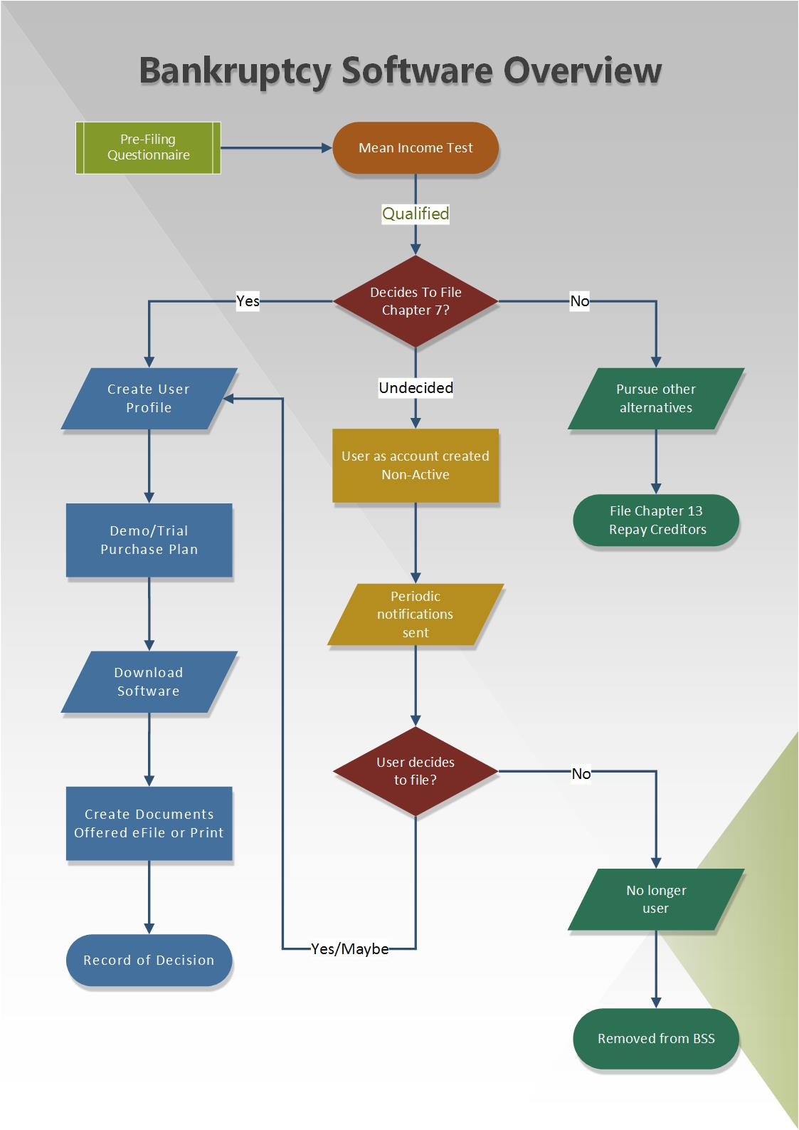

## **2.3 User Characteristics**

There are three types of users that interact with the PBS software: Individual users, Attorney and the administrator. Each of these three types of users has different use of the system, therefore each of them has their own requirements.

*The individual users will have to create a login only be to access one filing case.*

## **2.4 Constraints**

The “People’s Bankruptcy Software”

## **2.5 Assumptions and Dependencies**

*The purpose of this section is to give a detailed description of the assumptions and dependencies for the “People’s Bankruptcy Software”*

# **Requirements Overview**

This section gives a scope description and overview of everything included in this SRS document. Also, the purpose for this document is to described the entire system and document the requirements it takes to build the system. The figure below demonstrates the requirement gathering process that will used by the development team.

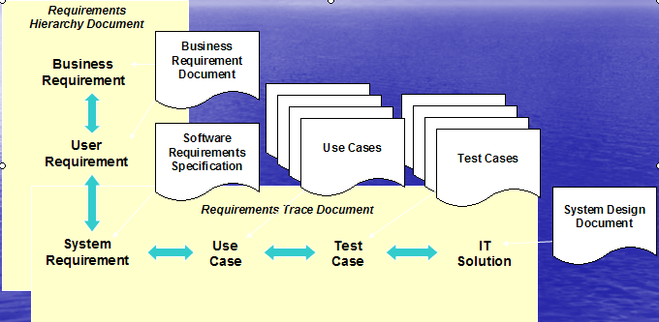

## 

## **3.1 System Interfaces**

This section provides a detailed description of all inputs into outputs from the system. It also gives a description of the hardware, software and communication interfaces and provides basic prototypes of the user interface.

### **3.1.1 User Interfaces**

As first time user of the Bankruptcy application you should see New user/Login page when he/she enters the software. The following workflow illustrates the interaction between the UI web pages.

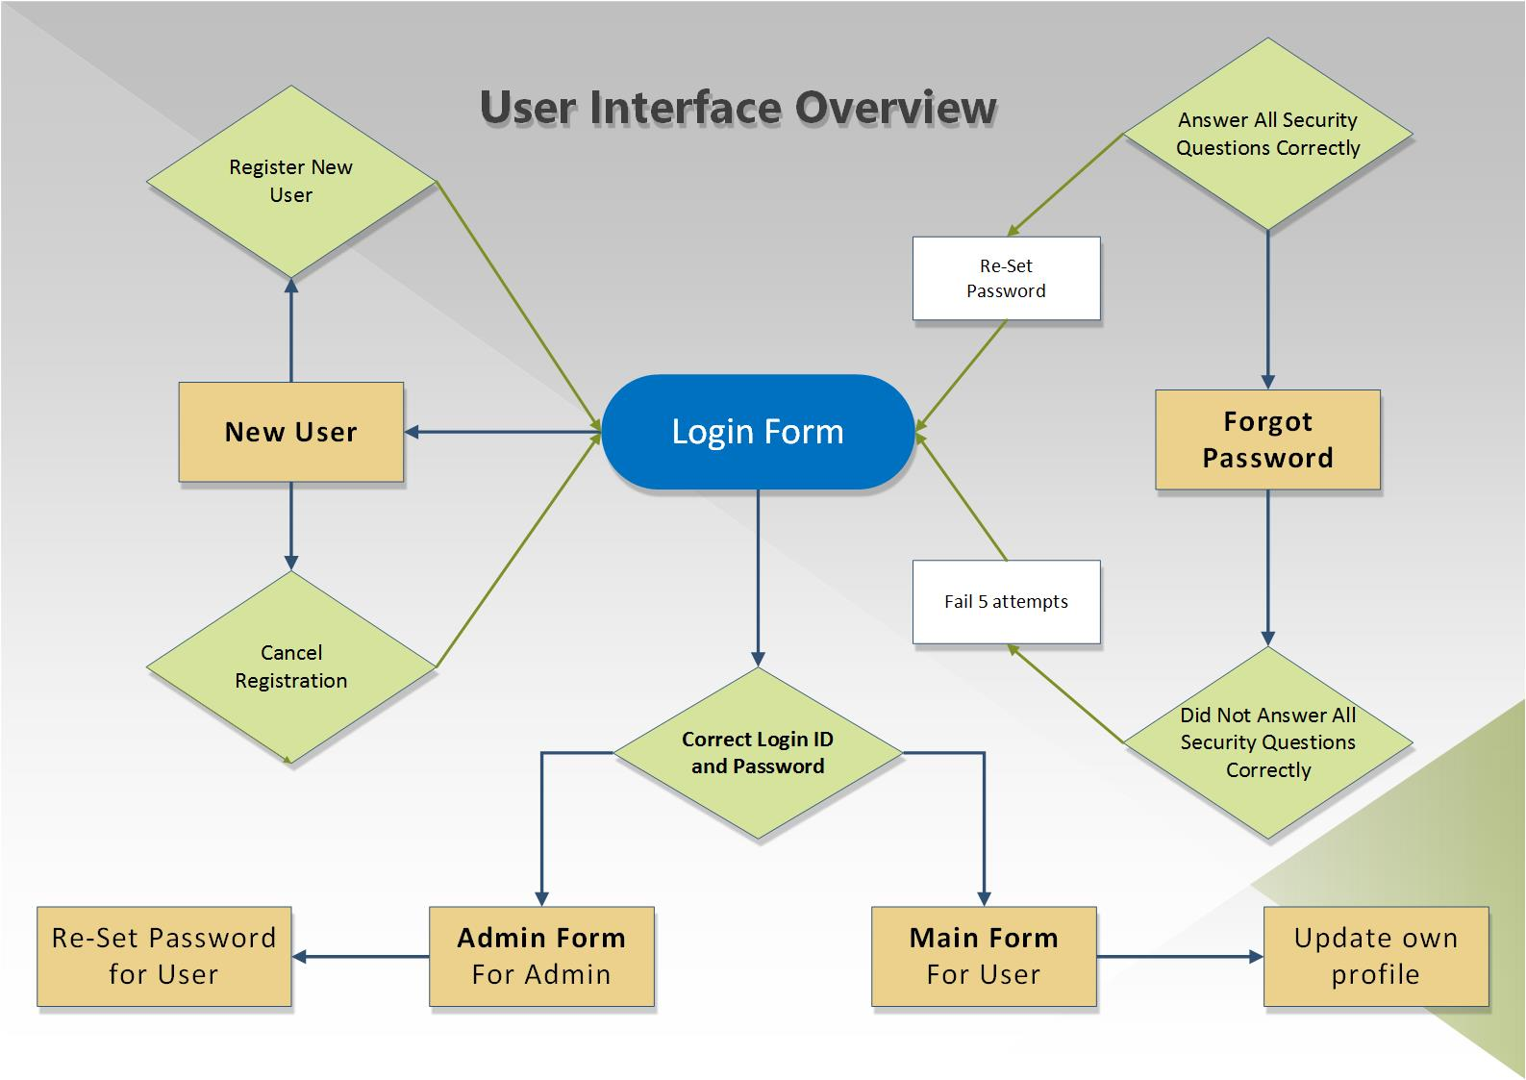

Evaluating User’s Step 1 – 5

### **3.1.2 Case Management Interfaces**

### **3.1.3 Document Management Interfaces**

## **3.2 Detail Functional Requirements**

The purpose of this section is to give a detailed description of the requirements for the People’s Bankruptcy Software, and the interaction of the system. Below is a UML diagram illustrating the propose model for the software.

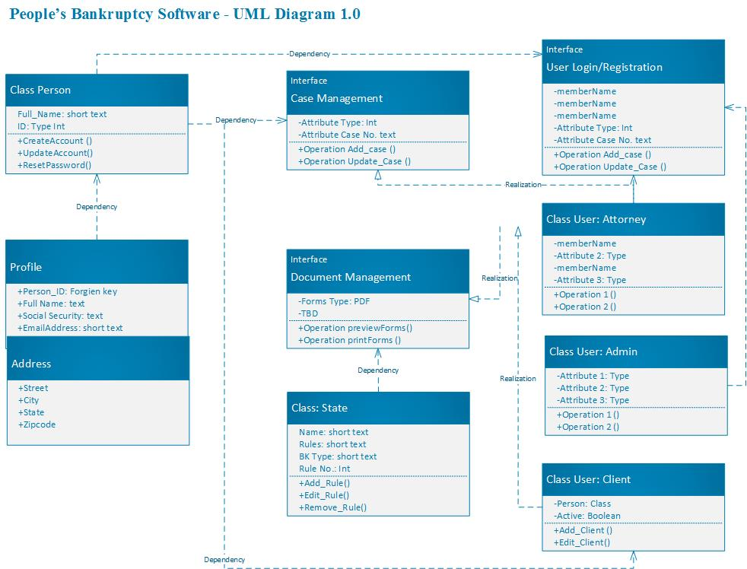

### **3.2.1 Manage User Accounts Requirements**

|  |  |  |  |  |  |
| --- | --- | --- | --- | --- | --- |
| **User Req** | UR |  |  |  |  |
| **High level Req** | H1 | **Manage User Accounts** | | | |
|  |  |  |  |  |  |
| **Req ID:** | UR-01 | **Req Type:** | User | **Use Case ID:** |  |
| **Description:** | Authenticate and Login user to the webapp | | | | |
| **Dependencies:** |  | | | | |
| **Priorty:** | High | | | | |
|  |  |  |  |  |  |
| **Req ID:** | UR-02 | **Req Type:** | User | **Use Case ID:** |  |
| **Description:** | Enable new users to register into the PBS system. If a user doesn’t have an account but would like to make one, this brings them onto the registration page. | | | | |
| **Dependencies:** |  | | | | |
| **Priorty:** | High | | | | |
|  |  |  |  |  |  |
| **Req ID:** | UR-03 | **Req Type:** | User | **Use Case ID:** |  |
| **Description:** | Enable a registered user to change his password if he forgets his password | | | | |
| **Dependencies:** |  | | | | |
| **Priorty:** | High | | | | |
|  |  |  |  |  |  |
| **Req ID:** | UR-04 | **Req Type:** | User | **Use Case ID:** |  |
| **Description:** | Enable a registered user to update his/her profile locations, which includes security questions. | | | | |
| **Dependencies:** |  | | | | |
| **Priorty:** | High | | | | |
|  |  |  |  |  |  |
| **Req ID:** | UR-05 | **Req Type:** | User | **Use Case ID:** |  |
| **Description:** | Email Confirmation - You need to make sure that you verify a user's email address as part of the sign-up process (I'd suggest not letting them login until it's confirmed). You'll need to have this for use in password resets | | | | |
| **Dependencies:** | UR-01, | | | | |
| **Priorty:** | High | | | | |
|  |  |  |  |  |  |
| **Req ID:** | UR-06 | **Req Type:** | User | **Use Case ID:** |  |
| **Description:** | Enable a Registration link directly below Login box. | | | | |
| **Dependencies:** | UR-02 | | | | |
| **Priorty:** | High | | | | |
|  |  |  |  |  |  |
| **Req ID:** | UR-07 | **Req Type:** | User | **Use Case ID:** |  |
| **Description:** | Users can finally access the PBS software - lands on home page | | | | |
| **Dependencies:** | UR-01,UR-02,UR-03 | | | | |
| **Priorty:** | High | | | | |
|  |  |  |  |  |  |
| **Req ID:** | UR-07 | **Req Type:** | User | **Use Case ID:** |  |
| **Description:** |  | | | | |
| **Dependencies:** |  | | | | |
| **Priorty:** | High | | | | |
|  |  |  |  |  |  |
| **Req ID:** | UR-07 | **Req Type:** | User | **Use Case ID:** |  |
| **Description:** |  | | | | |
| **Dependencies:** |  | | | | |
| **Priorty:** | High | | | | |

### **3.2.2 Case Management Requirements**

|  |  |  |  |  |  |
| --- | --- | --- | --- | --- | --- |
| **Business Req** | BR |  |  |  |  |
| **High Level Req** | H2 | Bankruptcy Case Management | | | |
|  |  |  |  |  |  |
| **Req ID:** | BR-2.01 | **Req Type:** | Business | **Use Case ID:** |  |
| **Description:** | Create new Chapter 7, 11, 12, or 13 case | | | | |
| **Dependencies:** |  | | | | |
| **Priorty:** | High | | | | |
| **Test Case ID:** |  | | | | |
|  |  |  |  |  |  |
| **Req ID:** | BR-2.02 | **Req Type:** | Business | **Use Case ID:** |  |
| **Description:** | A case must have multiple tabs that will be define by the case type workflow. Tabs not yet visted will be greyed out, with no user access. | | | | |
| **Dependencies:** |  | | | | |
| **Priorty:** | High | | | | |
| **Test Case ID:** |  | | | | |
|  |  |  |  |  |  |
| **Req ID:** | BR-2.03 | **Req Type:** | Business | **Use Case ID:** |  |
| **Description:** | A case must have the capability to have previously entered data updated and/or deleted | | | | |
| **Dependencies:** |  | | | | |
| **Priorty:** | High | | | | |
| **Test Case ID:** |  | | | | |
|  |  |  |  |  |  |
| **Req ID:** | BR-2.04 | **Req Type:** | Business | **Use Case ID:** |  |
| **Description:** | A case must be able track the user's state within the workflow, where the application will remenber last item/section work on. | | | | |
| **Dependencies:** |  | | | | |
| **Priorty:** | High | | | | |
| **Test Case ID:** |  | | | | |
|  |  |  |  |  |  |
| **Req ID:** | BR-2.05 | **Req Type:** | Business | **Use Case ID:** |  |
| **Description:** | A case must be able to add financial information as part of the workflow | | | | |
| **Dependencies:** |  | | | | |
| **Priorty:** | High | | | | |
| **Test Case ID:** |  | | | | |
|  |  |  |  |  |  |
| **Req ID:** | BR-2.06 | **Req Type:** | Business | **Use Case ID:** |  |
| **Description:** | A case must be able to add financial information as part of the workflow | | | | |
| **Dependencies:** |  | | | | |
| **Priorty:** | High | | | | |
| **Test Case ID:** |  | | | | |
|  |  |  |  |  |  |
| **Req ID:** | BR-2.07 | **Req Type:** | Business | **Use Case ID:** |  |
| **Description:** | A case must be able to conduct the Mean Test as part of the workflow | | | | |
| **Dependencies:** |  | | | | |
| **Priorty:** | High | | | | |
| **Test Case ID:** |  | | | | |
|  |  |  |  |  |  |
| **Req ID:** | BR-2.08 | **Req Type:** | Business | **Use Case ID:** |  |
| **Description:** | A Case must be able to add and display the financial informtion as part of the workflow | | | | |
| **Dependencies:** |  | | | | |
| **Priorty:** | High | | | | |
| **Test Case ID:** |  | | | | |
|  |  |  |  |  |  |
| **Req ID:** | BR-2.09 | **Req Type:** | Business | **Use Case ID:** |  |
| **Description:** | A case must be able to determine and recommend a bankruptcy type base on user financial data as part of the workflow - offering options only. | | | | |
| **Dependencies:** |  | | | | |
| **Priorty:** | High | | | | |
| **Test Case ID:** |  | | | | |
|  |  |  |  |  |  |
| **Req ID:** | BR-2.10 | **Req Type:** | Business | **Use Case ID:** |  |
| **Description:** | A case must be able to apply Federal rules and law base user financial data as part of the workflow - offering options only. | | | | |
| **Dependencies:** |  | | | | |
| **Priorty:** | High | | | | |
| **Test Case ID:** |  | | | | |
|  |  |  |  |  |  |
| **Req ID:** | BR-2.11 | **Req Type:** | Business | **Use Case ID:** |  |
| **Description:** | System must be able to apply State rules and laws base user financial data as part of the workflow - offering options only. | | | | |
| **Dependencies:** | BR-2.12 | | | | |
| **Priorty:** | High | | | | |
| **Test Case ID:** |  | | | | |
|  |  |  |  |  |  |
| **Req ID:** | BR-2.12 | **Req Type:** | Business | **Use Case ID:** |  |
| **Description:** | System must be able to apply federal rules and law base user financial data as part of the workflow - offering options only. | | | | |
| **Dependencies:** | BR-2.11 | | | | |
| **Priorty:** | High | | | | |
| **Test Case ID:** |  | | | | |

### **3.2.3 Document Management Requirements**

### **3.2.4 State / Federal Rules Engine**

### **3.2.5 Electronic filing (Pacer)**

### **3.2.6 Help system**

### **3.2.7 Security system**

## **3.3 Performance Requirements**

*The purpose of this document is to give a detailed description of the requirements for th*e

## **3.4 Security Requirements**

*The purpose of this document is to give a detailed description of the requirements for th*e

## **3.5 Design constraints**

*The purpose of this document is to give a detailed description of the requirements for the*

## **3.6 Software system attributes**

*The purpose of this document is to give a detailed description of the requirements for the*

# **Prioritization of Release Plans**

*This section gives a scope description and overview of everything included in this SRS document. Also, the purpose for this document is to described the system and create a list of abbreviations and definitions.*

# **Choice of prioritization Method**

*The purpose of this document is to give a detailed description of the requirements for the “People’s Bankruptcy Software” (ALL) software. It will illustrate the purpose and complete declaration for the development of system. It wi ll explain system*

# **Release Plan**

*The purpose of this document is to give a detailed description of the requirements for the “People’s Bankruptcy Software” (ALL) software. It will illustrate the purpose and complete declaration for the development of system.*

Future image for discussion above:

|  |  |
| --- | --- |
| **pixel.gif (42 bytes)Appendix A:**   |  | | --- | | **Bankruptcy Glossary** |     **Terms and descriptions**  Bankruptcy has its own language.  Here is a brief definition of those terms used in this site and in the Bankruptcy Code.  **Adequate protection:**Payment to a secured creditor to protect the value of the creditor's lien during the bankruptcy proceeding from loss due to depreciation or non-payment of a senior lien.  **Adversary proceeding**: A lawsuit filed in the bankruptcy court which is related to the debtor's bankruptcy case. Examples are complaints to determine the dischargeability of a debt and complaints to determine the extent and validity of liens.  **Assets:**Assets are every form of property that the debtor owns.  They include such intangible things as business goodwill; the right to sue someone; or stock options.  The debtor must disclose all of his assets in the bankruptcy schedules;  [exemptions](http://www.moranlaw.net/glossary.htm#Exempt) remove the exempt assets from [property of the estate](http://www.moranlaw.net/glossary.htm#Property of the estate).   **Automatic stay**: The injunction issued automatically upon the filing of a bankruptcy case which prohibits collection actions against the debtor, the debtor's property or the property of the estate.  See [Relief from Stay](http://www.moranlaw.net/stayrelief.htm) on terminating the injunction.  **Avoidance:**  The Bankruptcy Code permits the debtor to eliminate (avoid) some kinds of liens that interfere with (or impair) an [exemption](http://www.moranlaw.net/glossary.htm#Exemptions)  claimed in the bankruptcy.  Most judgment liens that have attached to the debtor's home can be avoided if the total of the liens (mortgages, judgment liens and statutory liens) is greater than the value of the property in which the exemption is claimed.  This is sometimes called "lien stripping."  For more, see [Lien Avoidance](http://www.moranlaw.net/lien.htm) and [Lien Stripping](http://www.moranlaw.net/lienstripping.htm).  **Avoidance powers**: Rights given to the bankruptcy trustee (or the debtor in possession in a Chapter 11) to recover certain transfers of property such as [preferences](http://www.moranlaw.net/glossary.htm#Preference)  or fraudulent transfers or to void [liens](http://www.moranlaw.net/glossary.htm#Lien)created before the commencement of a bankruptcy case.  More on [preferences.](http://www.moranlaw.net/preferences.htm)  **Bankruptcy Code**. Title 11 of the United States Code governs bankruptcy proceedings. Bankruptcy is a matter of federal law and is, with the exception of exemptions, the same in every state.  When federal bankruptcy law conflicts with state law, federal law controls. Bankruptcy [Code incorporating changes](http://www.weberlaw.com/BARF/barf-code-index.htm) effective 10/17/2005.  **Bankruptcy estate**: The estate is all of the legal and equitable interests of the debtor as of the commencement of the case. From the estate, an individual debtor can claim certain property [exempt](http://www.moranlaw.net/glossary.htm#Exemptions); the balance of the estate is liquidated in a Chapter 7 to pay the administrative costs of the proceeding and the claims of creditors according to their priority.  [More](http://www.moranlaw.net/property.htm)on the estate  **Chapter 7**: The most common form of bankruptcy, a Chapter 7 case is a liquidation proceeding, available to individuals, married couples, partnerships and corporations. More in [Bankruptcy Basics](http://www.moranlaw.net/bankruptcybasics.htm).  **Chapter 11**: A reorganization proceeding in which the debtor may continue in business or in possession of its property as a fiduciary. A [confirmed](http://www.moranlaw.net/glossary.htm#Confirmation) Chapter 11 plan provides for the manner in which the claims of creditors will be paid in whole or in part by the debtor.  **Chapter 12**: A simplified reorganization plan for family farmers whose debts fall within certain limits.  **Confirmed:**A plan of reorganization in Chapter 11, 12 or 13 approved by the court and binding on the parties is said to be confirmed.  **Chapter 13**: A repayment plan for individuals with debts falling below statutory levels which provides for repayment of some or all of the debts out of future income over 3 to 5 years.  More in [The Power of 13.](http://www.moranlaw.net/why13.htm)  **Charged Off**: This is an accounting term that means the creditor does not expect to collect on the debt. It relates to the creditor's taxes. It starts time periods under the Fair Credit Reporting Act. It does not mean that the debt is no longer legally enforceable.  **Collateral:**  The property which is subject to a [lien](http://www.moranlaw.net/glossary.htm#Lien).  A  creditor with rights in collateral is a secured creditor and has additional protections in the Bankruptcy Code for the claim secured by collateral.  The measure of the secured claim is the value of the collateral available to secure the claim:  it is possible to have a lien on property that is subject to a senior lien or liens such that the security available to pay the claim is really without value to the junior creditor.   The general rule with respect to liens is "First in time, first in right."   More on [Secured Debts](http://www.moranlaw.net/secured.htm).  **Confirmation**: The court order which makes the terms of the plan for repayment of debts in a Chapter 11, 12 or 13 binding. The terms of the confirmed plan replace the [prepetition](http://www.moranlaw.net/glossary.htm#Pre-petition:) rights of the [debtor](http://www.moranlaw.net/glossary.htm#Debtor) and creditor.  **Consumer Debt** Debts incurred by an individual for personal, family or household purposes. Taxes are not consumer debts; neither are business loans. The [means test](http://www.moranlaw.net/means_test.htm) only applies to those with primarily consumer debt.  **Contingent:** Used to describe debts that are not fixed in right at the time, but are dependent on some other event happening to fix the liability.  **Conversion**: Cases under the Code may be converted from one chapter to another chapter; for example, a Chapter 7 case may be converted to a case under Chapter 13 if the debtor is eligible for Chapter 13.  Even though the chapter of the Code which governs it changes, it remains the same case as originally filed.  **Creditor:**  The person or organization to whom the debtor owes money or has some other form of legal obligation.  **Debtor:**  The debtor is the entity ( person, partnership or corporation) who is liable for debts, and who is the subject of a bankruptcy case.  **Debtor in Possession:** In a Chapter 11 case, the debtor usually remains in possession of its assets and assumes the duties of a trustee.  The debtor in possession is a [fiduciary](http://www.moranlaw.net/glossary.htm#Fiduciary:) for the creditors of the estate, and owes them the highest duty of care and loyalty.  **Denial of discharge**:   Penalty for debtor misconduct with respect to the bankruptcy case or creditors as a whole.  The grounds on which the debtor's discharge may be denied are found in 11 U.S.C. 727.  When the debtor's discharge is denied, the debts that could have been discharged in that case cannot be discharged in any subsequent bankruptcy.  The administration of the case, the liquidation of assets and the recovery of avoidable transfers, continues for the benefit of creditors.   More on [denial of discharge.](http://www.moranlaw.net/nodischarge.htm)  **Discharge**: The legal elimination of debt through a bankruptcy case. When a debt is discharged, it is no longer legally enforceable against the debtor, though any [lien](http://www.moranlaw.net/glossary.htm#Lien) which secures the debt may survive the bankruptcy case.  **Dischargeable**: Debts that can be eliminated in bankruptcy.  Certain debts  are not dischargeable;  that it, they may not be [discharged](http://www.moranlaw.net/glossary.htm#Discharge) through bankruptcy or may only be discharged through Chapter 13. Family support and criminal restitution are examples of debts which cannot be discharged. Debts incurred by fraud can only be discharged in Chapter 13.  More on [which debts can be discharged](http://www.moranlaw.net/7discharge.htm).  [Considerations in contesting discharge of a debt.](http://www.moranlaw.net/contesting.htm)  **Dismissal**: The termination of the case without either the entry of a [discharge](http://www.moranlaw.net/glossary.htm#Discharge)or a denial of discharge; after a case is dismissed, the debtor and the creditors have the same rights as they had before the bankruptcy case was commenced. Dismissal is the penalty for many essentially minor infractions of bankruptcy procedures under the 2005 amendments.  **Domestic Support Obligation**: Debts for alimony, maintenance or support owed to child, spouse or governmental entity that paid for the support of the child or spouse. A new term introduced by the bankruptcy amendments of '05.  **Exempt:**     Property that is exempt is removed from the bankruptcy estate and is not available to pay the claims of creditors.  The debtor selects the property to be exempted from the statutory lists of exemptions available under the law of his state.  The debtor gets to keep exempt property for use in making a fresh start after bankruptcy.  More on [Exemptions.](http://www.moranlaw.net/exemptions.htm)  **Exemptions**:   Exemptions are the lists of the kinds and values of property that is legally beyond the reach of creditors or the bankruptcy trustee.  The debtor in bankruptcy keeps the exempt property. What property may be exempted is determined by state and federal statutes, and varies from state to state. [More](http://www.moranlaw.net/exemptions.htm) on exemptions.  **Fiduciary:**  one who is entrusted with duties on behalf of another.  The law requires the highest level of good faith,  loyalty and diligence of a fiduciary, higher than the common duty of care that we all owe one another.  The debtor in possession in a Chapter 11 is a fiduciary for the creditors, owing loyalty to the creditors and not the shareholders of the debtor.  **General, unsecured claim:** Creditor's claim without a [priority](http://www.moranlaw.net/glossary.htm#Priority) for payment for which the creditor holds no[security](http://www.moranlaw.net/glossary.htm#Collateral:)(or collateral). If the available funds in the estate extend to payment of unsecured claims, the claims are paid in proportion to the size of the claim relative to the total of claims in the class of unsecured claims.  **Indemnify:**to guarantee against any loss which another might suffer. In bankruptcy, it is used to describe the undertaking of one spouse in a divorce to assume certain debts of the marriage and to see that the other spouse is not forced to pay. Also called a "hold hamrless" clause.  **Lien**: An interest in real or [personal property](http://www.moranlaw.net/glossary.htm#Personal property) which secures a debt; the lien may be voluntary, such as a mortgage in real property, or involuntary, such as a judgment lien or tax lien.  **Liquidated:**A debt that is for a known number of dollars is liquidated.  An unliquidated debt is one where the debtor has liability, but the exact monetary measure of that liability is unknown.  Tort claims are usually unliquidated until a trial fixes the amount of the liability of the tort feasor.  **Means Test:**Added to the Code in 2005, the means test is intented to screen out those filing Chapter 7 who are supposedly able to repay some part of their debts. The test is found in Official Form [B22a](http://www.moranlaw.net/Form_22A_1006.pdf). Debtors who fail the means test may convert their case to another chapter of bankruptcy. More about [how the means test works](http://www.moranlaw.net/means_test.htm).  **Meeting of creditors**The debtor must appear at a meeting with the trustee to be examined under oath about assets and liabilities.  Creditors are invited but seldom attend.  The meeting is sometimes called the 341 meeting, after the section of the Bankruptcy Code that requires it.  [More](http://www.moranlaw.net/341.htm) about "going to court".  **Non dischargeable**:   A debt that cannot be eliminated in bankruptcy.  Non dischargeable debts remain legally enforceable despite the bankruptcy discharge.  The Code's list of non dischargeable debts is found at [11 U.S.C. 523](http://www.law.cornell.edu/uscode/11/523.html). The scope of the discharge in Chapter 13 differs from the discharge in Chapter 7.[Discharges compared.](http://www.moranlaw.net/bankruptcy_discharge_compared.htm)  **Perfection:**  When a secured creditor has taken the required steps to perfect his lien, the lien is senior to any liens that arise after perfection.  A mortgage is perfected by recording it with the county recorder;  a lien in personal property is perfected by filing a financing statement with the secretary of state.  An unperfected lien is valid between the debtor and the secured creditor, but may be behind liens created later in time, but perfected earlier than the lien in question.  An unperfected lien can be [avoided](http://www.moranlaw.net/glossary.htm#Avoidance) by the trustee.  **Personal property**: Assets, such as cars, stock, furniture, etc., that is not real estate or affixed to real property,   **Petition**: The document that initiates a bankruptcy case. The filing of the petition constitutes an order for relief and institutes the [automatic stay](http://www.moranlaw.net/glossary.htm#Automatic stay).   Events are frequently described as "prepetition", happening before the bankruptcy petition was filed, and "post petition", after the bankruptcy was initiated.  **Preference**: A transfer to a creditor in payment of an existing debt made within certain time periods before the commencement of the case. Preferences may be recovered by the [trustee](http://www.moranlaw.net/glossary.htm#Trustee) for the benefit of all creditors of the estate. [More on preferences](http://www.moranlaw.net/preferences.htm).  **Pre-petition**: Claims or events arising before the commencement of the bankruptcy case, that is, before the filing of the bankruptcy petition.  Generally only pre petition debts may be [discharged](http://www.moranlaw.net/glossary.htm#Discharge) in a bankruptcy proceeding.  **Priority:**  The Bankruptcy Code establishes the order in which claims are paid from the bankruptcy estate.  All claims in a higher priority must be paid in full before claims with a lower priority receive anything.  All claims with the same priority share pro rata.  Claims are paid in this order:  1) costs of administration  2) [priority claims](http://www.moranlaw.net/glossary.htm#Priority claims) and 3) general unsecured claims.  Secured claims are paid from the proceeds of liquidating the collateral which secured the claim.  **Priority claims**: Certain debts, such as unpaid wages, spousal or child support, and taxes are elevated in the payment hierarchy under the Code. Priority claims must be paid in full before [general unsecured claims](http://www.moranlaw.net/glossary.htm#General, unsecured claim) are paid.[Priorities listed](http://www.moranlaw.net/priorities.htm). [Discussion of priority taxes](http://www.moranlaw.net/taxes.htm).  **Proof of claim**: The form filed with the court establishing the creditor's claim against the debtor.  **Property of the estate:**  The property that is not exempt and belongs to the bankruptcy estate.  Property of the estate is usually sold by the trustee and the claims of creditors paid from the proceeds.  [More](http://www.moranlaw.net/property.htm)on property of the estate.  **Reaffirm:**  The debtor can chose to waive the discharge as to a debt that is reaffirmed. Generally, the parties to the reaffirmed debt have the same rights and liabilities that each had prior to the bankruptcy filing: the debtor is obligated to pay and the creditor can sue or repossess if the debtor doesn't pay.  [More](http://www.moranlaw.net/secured7.htm) on reaffirmation and the alternatives.  **Relief from stay**:  A creditor can ask the judge to lift the [automatic stay](http://www.lawguru.com/lawlinks/Bankruptcy/#Automatic stay)and permit some action against the debtor or the property of the estate.  If the motion is granted, the moving party (but no one else) is free to take whatever action the court permits.  Relief can be absolute, for example, permitting the creditor to foreclose on property, or limited, as for example, allowing the recordation of a notice of default.  More on [relief from stay](http://www.moranlaw.net/stayrelief.htm).  **Schedules:**The debtor must file the required lists of assets and liabilities to commence a bankruptcy case, collectively called the schedules.  **Secured debt:**   A claim secured by a [lien](http://www.moranlaw.net/glossary.htm#Lien) in the debtor's property by reason of  the debtor's agreement  or an involuntary lien such as a judgment or tax lien. The creditor's claim may be divided into a secured claim, to the extent of the value of the collateral, and an [unsecured claim](http://www.moranlaw.net/glossary.htm#General, unsecured claim) equal to the remainder of the total debt. Generally a secured claim must be [perfected](http://www.moranlaw.net/glossary.htm#Perfection:) under applicable state law to be treated as a secured claim in the bankruptcy. More at [Is This Debt Secured?](http://www.moranlaw.net/secured.htm)  **Trustee:**the court appoints a trustee in every Chapter 7 and Chapter 13 case to review the debtor's schedules and represent the interests of the creditors in the bankruptcy case.  The role of the trustee is different under the different chapters.  [More](http://www.moranlaw.net/trustee.htm) on trustees.  **Unsecured**:  A claim or debt is unsecured if there is no [collateral](http://www.moranlaw.net/glossary.htm#Collateral:) that is security for the debt.  Most consumer debts are unsecured.  See [Is This Debt Secured](http://www.moranlaw.net/secured.htm)? |